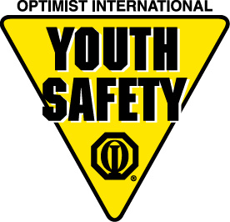

**FARGO SAFETY TOWN**

Sponsored by: Fargo Optimist Club, in cooperation with the Fargo Police and Fire Departments and Fargo Public Schools

SAFETYTOWN is a 20-hour course where children learn safety procedures through involvement in both classroom and outdoor instruction. The six two-week sessions held during the summer are specifically geared toward incoming kindergarten children, and each summer over 400 area students participate in the program.

Specific topics covered are: pedestrians, fires, strangers, pets and animals, traffic signs and signals, poisons, buses, and general play at school and at home. The program is taught by professional teachers. Visits by Fargo Police and Fire Department officers provide children with enjoyable learning experiences.

The Fargo Optimist Club supports the program by paying the professional teaching staff. A small registration fee for children helps to cover some of the costs of keeping learning materials updated. We are looking for civic-minded businesses to help sponsor the remainder of material costs as well as the t-shirts each child receives when they enter the program. Your business name will appear on the t-shirts as a Safety Town Sponsor and other promotions.

Please send your sponsorship of this valuable community program to the Fargo Optimist Club – Attn: Safety Town 2601 39½ Ave S Fargo, ND 58104.

Thank you in advance for your consideration!

­­­

Yes, we would like to be a Safety Town sponsor at the following level:

Name of Business: \_\_\_\_\_\_\_\_\_\_\_\_\_\_\_\_\_\_\_\_\_\_\_\_\_\_\_\_\_\_

$100 $250

$500 $1000

**Please make sponsorship checks to: Fargo Safety Town**

**THANK YOU!!**

**MCTN00704_0000[1]MCj04046010000[1]MCj04112440000[1]**